**Stress Prediction**

**ABSTRACT:**

A prediction is an android application system that strain is now identified as one of the fundamental causes of physical and mental illness. It is called a response to surrounding environmental threats and the pleasant way to manage it's far to understand its triggers. Although people continuously react to their surrounding environments, they sometimes aren't conscious that certain factors in their environment are considered to be stressors. Based in this fact, researchers have these days proposed context-aware pressure management structures. Most of the proposed systems use context data to provide real time pressure tracking and visualization, at the side of intervention techniques. So, the user strain can be predicate in our application to user deliver a capturing picture on the display and to detect an emotion process may be checking subsequently the user relief a stress the usage of software.

**INTRODUCTION:**

Every day, humans face a number of one-of-a-kind challenges and obstacles. The human frame has been designed to address such challenges and tough tasks by way of reacting to threats to the thoughts or the frame. The human being’s capacity to protect itself and take dangers to save its lifestyles is due Eustress is a superb sort of strain produced with the aid of our bodies to triumph over demanding situations, face our fears, meet deadlines, write checks and communicate publicly. Stress can be positive while it helps motivate us and encourages us to take action. However, experiencing an excessive amount of pressure for a long period of time can be overwhelming and can have negative outcomes on our bodily and mental wellbeing. This sort of problematic strain is referred to as distress. There are sturdy associations between strain and certain sever issues. The American Institute lists more than 50 signs of pressure and problems associated with pressure. A few examples of such disorders include: headaches, coronary heart attacks, and depression. Moreover, humans who revel in high ranges of stress have extra odds of developing malignant-tumors. Stress also can contribute in a roundabout way to illnesses which can be associated with unhealthy conduct that generally tend to boom beneath excessive strain, for instance smoking and lack of sleep. Whenever a risk is present, human beings can adjust their pressure status by way of activating the sympathetic that is the branch accountable for triggering the “fight or flight response. Based on the fact that pressure is ubiquitous, threats can be both internal and external. After facing the hazard with both a combat and a flight response, the other is activated to calm the body. From the five stressors categories that classified based totally on duration defined in we decided to consciousness on the acute time restricted stressors, as human beings face this type of stressors greater frequently.

**EXISTING SYSTEM & PROPOSED SYSTEM**

**EXISTING SYSTEM: -**

In existing framework given solution the users have to first get themselves the designed with different stress recognition and management methods, based on their final goal, whether that is stress detection, monitoring and visualizing, or management. Face recognition is being used in a variety of real-world applications nowadays. Despite of its importance, face recognition process still contains many issues like changes in face expressions, pose variations, occlusions and illumination. Face is incredibly a crucial part of human body that is visually used for recognition purpose. A facial expression is a means of nonverbal communication that plays a vital role to exchange impressions between one another.

**Drawbacks:**

* Existing systems for mood prediction are that mood is treated as a binary state
* The lowest possible mood score is treated as equivalent to a slightly lower than average score.

**PROPOSED SYSTEM: -**

A proposed context-aware stress management system. Most of the proposed systems use context data to provide real time stress monitoring and visualization.

**Advantages:**

* Its personalization can provide advantages in predicting mood and wellbeing, a problem where interindividual variability is high.
* Face expression natural non-verbal emotional communication method.

**MODULES**

* **Login and Registration**
* **Database Creation**
* **Capturing Screen**
* **Emotion Detection**
* **Stress Relief**

**LOGIN AND REGISTRATION:**

In this module we design to develop sign in and signup screen. We have two types of user namely customer and farmer. Android used xml to develop classical screens in our application. The sign in page for customer contains id and password, after confirming, if it matches Password to allow in the app otherwise alert an error Dialog and show a message to the user. The sign in for Manager contains id and Password, after confirming, if it matches Password to allow in the app otherwise alert an error Dialog and show a message to the user.

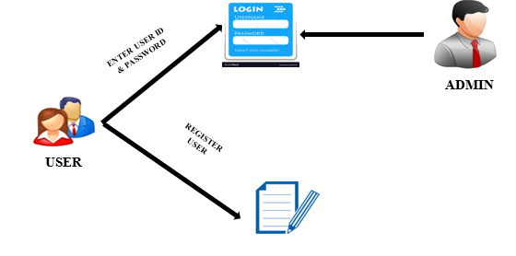

**DATABASE CREATION**

In the Database Creation Module, admin only has the rights to register an new user for both parent and Drivers. We want to store all details at cloud.so with the help of PHP and JSON we store all the data to the MYSQL database at cloud.



**CREATE THE TABLE IN JAVA CODE**

**REGISTRATION**

**DETAILS**

**DATABASE**

**USER**

**CAPTURING SCREEN:**

In this module we have to develop a capturing a user face on the screen and capture the picture to store in Database storage. So, capturing screen module the user face can access using an application.

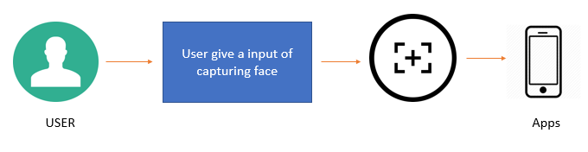

**EMOTION DETECTION:**

In this module we have to create an emotion detection the user face input gets on the screen to a solution for facial expression recognition that uses a combination specific image pre-processing step. It described the innovative solution that provides efficient face expression.

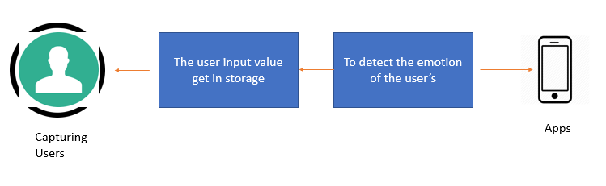

**STRESS RELIEF:**

In this module we have implement the stress relief to analysis the user information of through this apps. The stress relief process is analysis the result of the user face expression and the data can be stored. The user helps to breathing exercise are implement of the stress relief using an application.

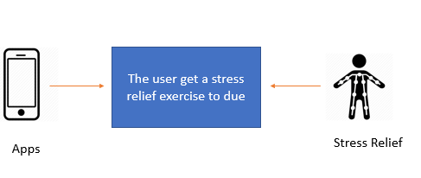

**CHAPTER 4**

**DESIGN ENGINEERING**

**4.1 GENERAL**

Design Engineering deals with the various UML [Unified Modelling language] diagrams for the implementation of project. Design is a meaningful engineering representation of a thing that is to be built. Software design is a process through which the requirements are translated into representation of the software. Design is the place where quality is rendered in software engineering. Design is the means to accurately translate customer requirements into finished product.

**DIAGRAMS:**

**USE CASE:**

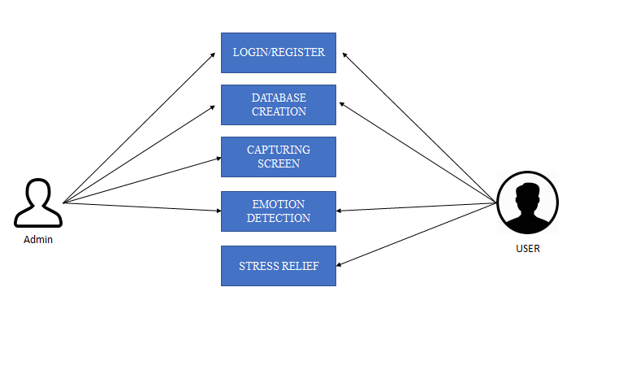

**Explanation:**

Use case diagrams are considered for high level requirement analysis of a system. So, when the requirements of a system are analyzed the functionalities are captured in use cases. So, we can say that uses cases are nothing but the system functionalities written in an organized manner. Now the second things which are relevant to the use cases are the actors. Actors can be defined as something that interacts with the system. The actors can be human user, some internal applications or may be some external applications.

Functionalities to be represented as a use case, Actors and Relationships among the use cases and actors. The name of a use case is very important. So, the name should be chosen in such a way so that it can identify the functionalities performed. Give a suitable name for actors. Show relationships and dependencies clearly in the diagram. Do not try to include all types of relationships. Because the main purpose of the diagram is to identify requirements. Use note whenever required to clarify some important points.

**ACTIVITY DIAGRAM:**

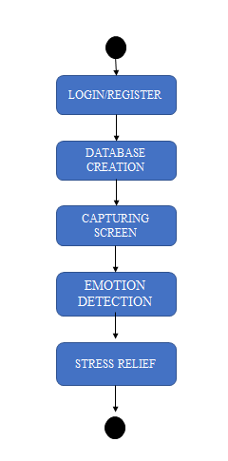

**Explanation**:

Activity is a particular operation of the system. Activity diagrams are not only used for visualizing dynamic nature of a system but they are also used to construct the executable system by using forward and reverse engineering techniques. The only missing thing in activity diagram is the message part.

It does not show any message flow from one activity to another. Activity diagram is some time considered as the flow chart. Although the diagrams look like a flow chart but it is not. It shows different flow like parallel, branched, concurrent and single.

**CLASS DIAGRAM:**

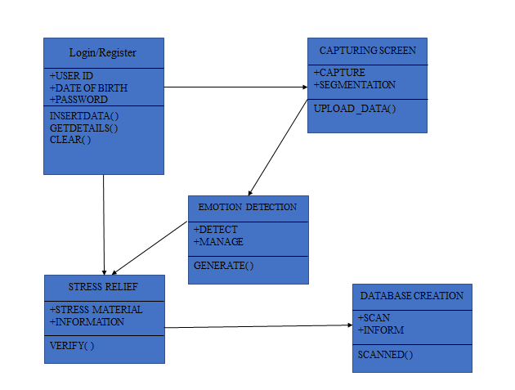

**Explanation**:

Class diagram is basically a graphical representation of the static view of the system and represents different aspects of the application. So, a collection of class diagrams represents the whole system. The name of the class diagram should be meaningful to describe the aspect of the system. Each element and their relationships should be identified in advance Responsibility (attributes and methods) of each class should be clearly identified for each class minimum number of properties should be specified

**SEQUENCE DIAGRAM:**

**DATABASE CREATION**

**EMOTION DETECTION**

**CAPTURE SCREEN**

**REGISTRATION**

**LOGIN**

ALL DETAILS STORED IN DATA BASE

USER ID & PASSWORD

REFER RULES APPLY PROCESS

GET RESULT RESPONSE

**Explanation**:

UML sequence diagrams model the flow of logic within your system in a visual manner, enabling you both to document and validate your logic, and are commonly used for both analysis and design purposes. Sequence diagrams are the most popular UML artifact for dynamic modeling, which focuses on identifying the behavior within your system. Other dynamic modeling techniques include activity diagramming, communication diagramming, diagramming, and [interaction overview diagramming](http://agilemodeling.com/artifacts/interactionOverviewDiagram.htm), Sequence diagrams, along with [class diagrams](http://agilemodeling.com/artifacts/classDiagram.htm) and [physical data models](http://agiledata.org/essays/dataModeling101.html) are in my opinion the most important design-level models for modern business application development.

**COLLABORATION DIAGRAM:**

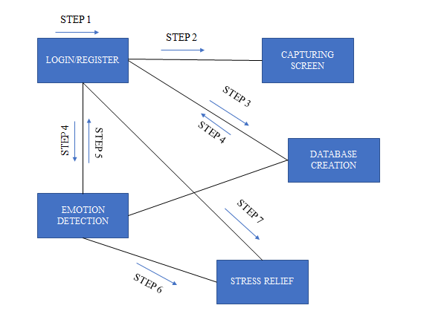

**Explanation**:

The second interaction diagram is collaboration diagram. It shows the object organization as shown below. Here in collaboration diagram the method call sequence is indicated by some numbering technique as shown below. The number indicates how the methods are called one after another. We have taken the same order management system to describe the collaboration diagram. The method calls are similar to that of a sequence diagram. But the difference is that the sequence diagram does not describe the object organization whereas the collaboration diagram shows the object organization. Now to choose between these two diagrams the main emphasis is given on the type of requirement. If the time sequence is important then sequence diagram is used and if organization is required then collaboration diagram is used.

**COMPONENT DIAGRAM:**

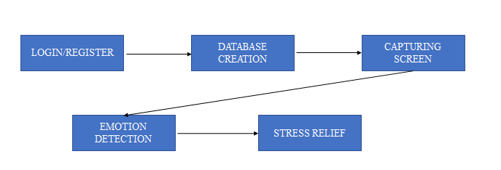

**Explanation**:

Component diagrams are used to describe the physical artifacts of a system. This artifact includes files, executable, libraries etc. So, the purpose of this diagram is different, Component diagrams are used during the implementation phase of an application. But it is prepared well in advance to visualize the implementation details. Initially the system is designed using different UML diagrams and then when the artifacts are ready component diagrams are used to get an idea of the implementation. This diagram is very important because without it the application cannot be implemented efficiently. A well-prepared component diagram is also important for other aspects like application performance, maintenance etc.

**SYSTEM REQUIREMENTS**

**HARDWARE REQUIREMENTS**

PROCESSOR : INTEL CORE I3.

RAM : 4 GB DDR2 RAM

MONITOR : 15” COLOR

HARD DISK : 100 GB

**SOFTWARE REQUIREMENTS**

FRONT END : ANDROID XML, JAVA

BACK END : SQLITE, PHP

OPERATING SYSTEM : WINDOWS 07

IDE : ECLIPSE, ANDROID STUDIO

**SYSTEM ARCHITECTURE:**

